Persona A-Freshman

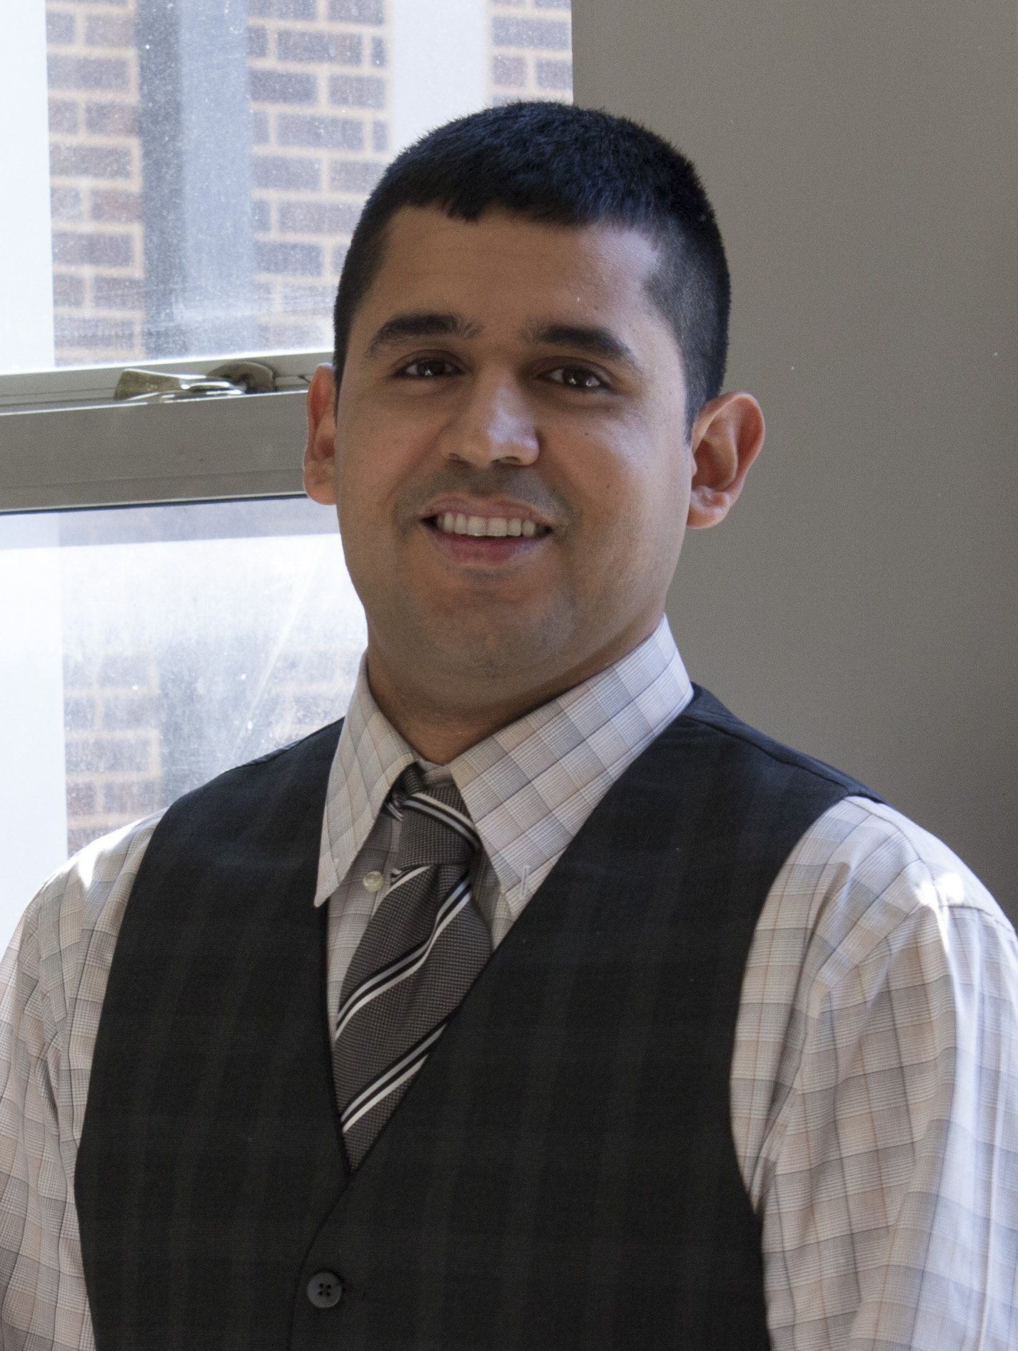
Name: Joseph
Age: 18

Education: Freshman
Mechanical Engineering,

Family:
Family is of Hispanic origin, residing in Fort Worth, TX. Has a sibling who is in High School and family isn’t very wealthy.

Stories, Quotes:
- “I am here on a scholarship, so I need to work hard and focus on my degree to get the best I can out of UNT. My Work Study at the cafeteria helps me keep my scholarship. I haven’t found it hard to adjust to life here since life back home was harder, with me being responsible for a number of chores other than school.”
- “I found the tour here at UNT very helpful in deciding on this University, other than the scholarships I received, since I realized that it was a diverse crowd here, which was what I wanted. The tour guides themselves were diverse, and the tour was quite informative.”

Scenarios, Questions:
- Joseph has started his Bachelor’s in Computer Science and is looking to gain as much knowledge from his UNT experience as he can. He’s finding the subjects quite easy, except History. Campus life isn’t too difficult either, since he lives in Residence Halls and has numerous friends. What can he do to diversify his social network? Who can he talk to, to make the subjects he finds difficult, simple?
- He wants to maximize the knowledge he wants to gain from UNT. What co-curricular or extra-curricular activities should he join to do this? He wants to gain experience in life by being at University. What should he do for this?

Persona B-Freshman
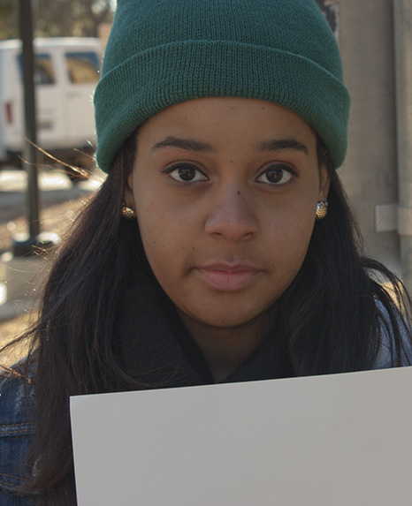
Name: Alex
Age: 19

Education: Freshman
Graphic Design,
Photography

Family:
Family is from Grapevine. She is an only child, from a broken home. She is the first in her family to attend college. She didn’t want to leave home, but she wanted to change her family situation. College was a means to an end. Since UNT was close it allowed her the opportunity to stay local and be with her mother.

Stories, Quotes:
- “That was frustrating because sometime they say you cant take this class because its reserved for certain students. But I was told I could take online classes, I was told I could take them but then you click them and it was like, “no this is reserved,” and you have to go the head of the department to ask for it. That’s very frustrating. If I should want to take online classes I should be able to take online classes.”
- “I guess like sometimes when I want to find very specific things, its very difficult to find. Like lets say I wanted to look at a specific organization on campus, but like something in that organization. You have to go to the UNT website and then you have to go find that organization and then you have to go and find that specific topic about that organization.”

Scenarios, Questions:
- Since Alex knew she was going to UNT, she didn’t apply to any other colleges, nor did she investigate any of her options once enrolled. Now that she is attending, and in her first year, she is finding the use of UNT systems to be problematic. She would like to know how she can enroll into her online course without constantly running back-and-forth. How can Alex better utilize Registrar to find her classes and take online courses?
- She would also like to be more involved with campus life and has looked at UNT systems for organizational information. The problem that she faces is she is unaware of which programs to look into. She is easily frustrated by the constant clicking to navigate through the different site pages. How can she find an organization to get involved in without searching through each organization?

Persona C-Transfer Student
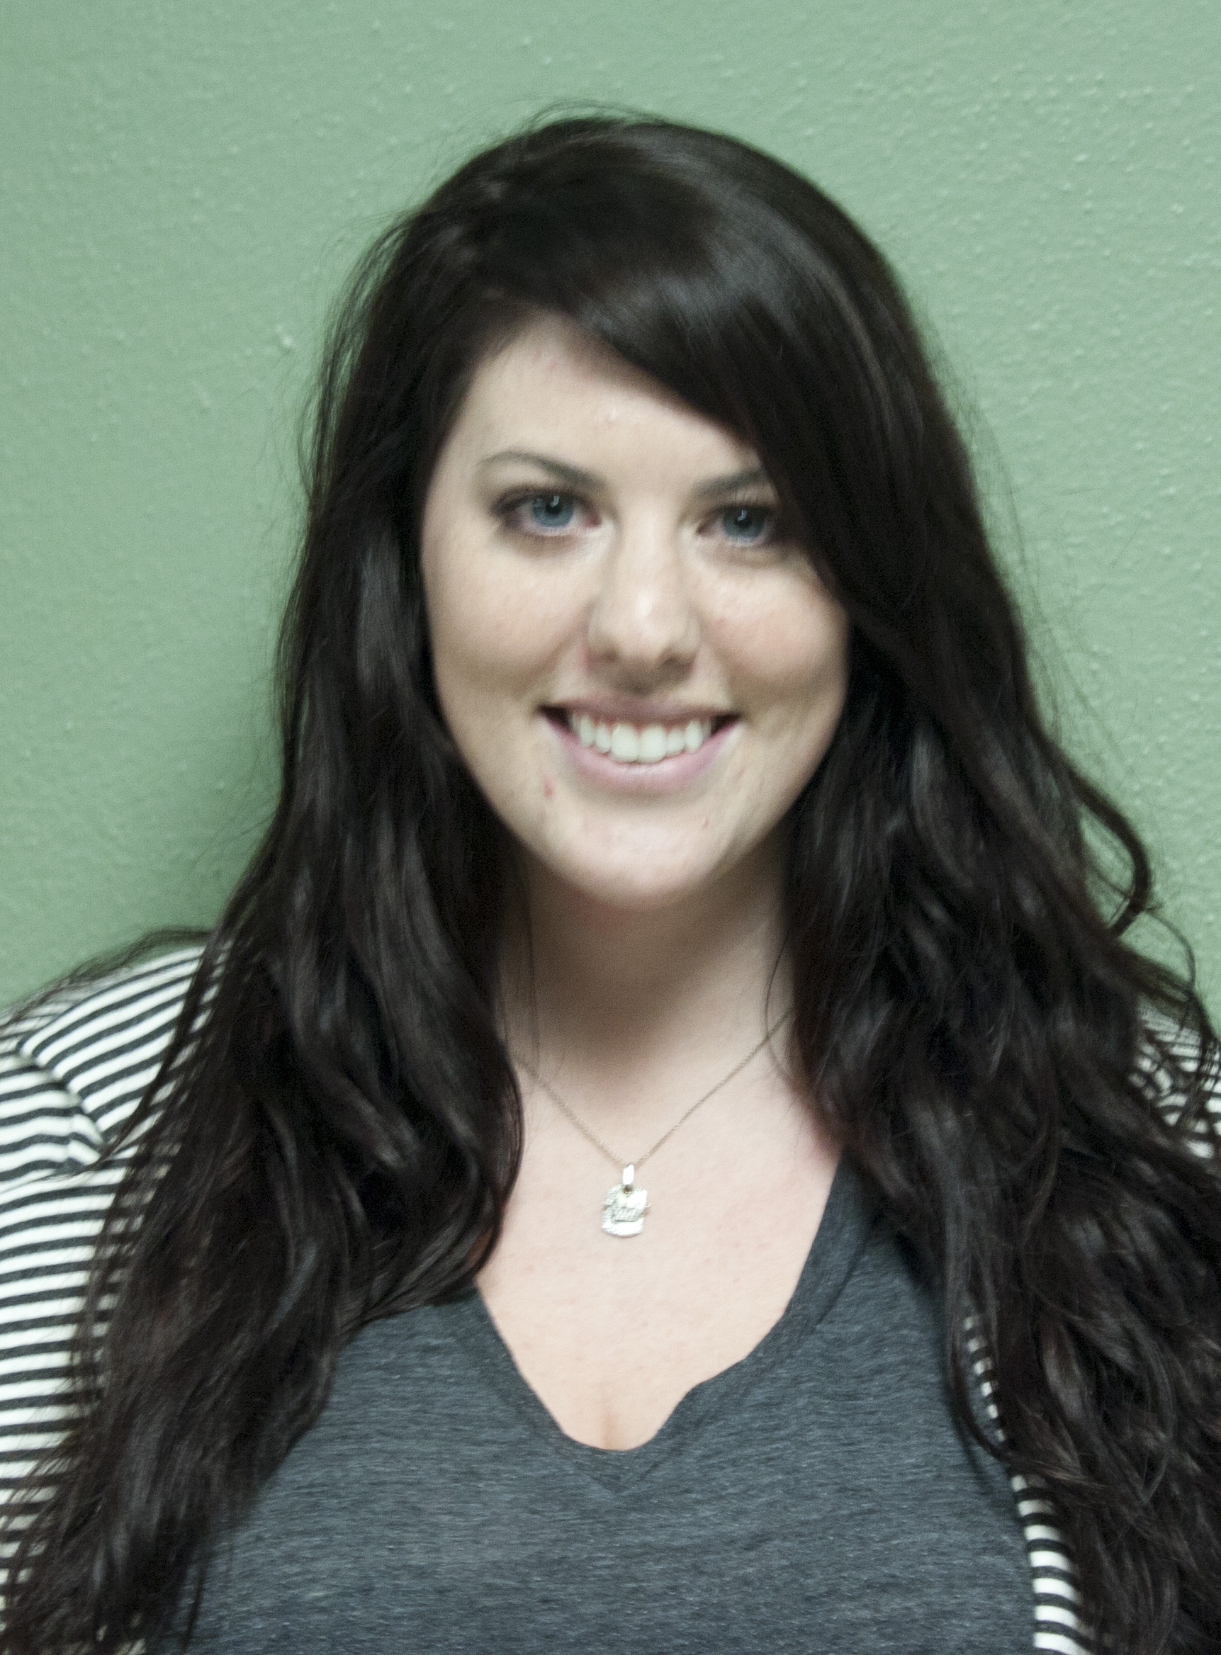
Name: Tina
Age: 22

Education: Transfer Student
Technical Communication

Family:
From a large family, mother and sisters are all UNT alumni, father graduated from Texas Tech. School is important and stressed in her household, with the message to enjoy every minute of it.

Stories, Quotes:
- “I choose UNT for it’s technical communication program. I want to develop my skills as a writer and eventually open my own consulting firm. I belong to the local STC, but I do not feel it is enough for to meet my end goals. I would like to get some help with being a role model, and I need to learn how to do more with computers.”
- “I’m not really involved in like sororities or have gone to a football game, but I don’t go because I live off campus. I think living off campus hurts me socially because I don’t get the opportunity to meet a lot of people and I’m really involved with that kind of stuff. Most of the stuff is in the evening, and I drive to and from school everyday.”

Scenarios, Questions:
- Tina would like to get a really nice job as a technical writer, which is why she choose UNT’s TechCom program, but she would like to develop her professional skills. What organizations can she look into to help develop her leadership skills? Where can she go to help develop her computer aptitude skills?
- Tina doesn’t mind doing extra-circular activities and would attend more school functions but the timing for of most events do not work with her schedule. The events UNT holds for transfer students are normally held in the evening and not well advertised. She has attended a few mixers but felt they events were thrown together with no purpose in mind. How can Tina be more involved with school events? Where can she find information on events that occur during the time she is at school?

Persona D-Female International Master’s Student

Name: Pooja
Age: 25

Education: International Master’s Student
Computer Science

Family:
Family of four from a small town in India. Father is a doctor and mother is in finance. Her sister is a recent graduate from UNT.

Stories, Quotes:
- “Yeah, there were other universities I looked at; I got admits from two of them, and even though the other one was good, I wasn’t sure I would be given as extensive employment opportunities while I’m in my program. I thought that UNT had the best one among the two others, so that’s why I came here.”
- “There were a lot of options for on-campus employment which basically helps a lot of international students in their living here.”

Scenarios, Questions:
- Pooja is working on her Master’s degree in computer science. She is a working professional in the field and has obtained her Bachelor’s degree from a university in India. She has sought out UNT for its diverse culture, and being from a similar small town in India, she felt Denton and UNT’s environment would help her transition well in the United States. She has been in the country for three months and has acclimated well with her surroundings. She is looking to establish her own social network and build lasting relations with the people she meets. She would like to find where she can become more involved with the UNT community.
- Employment opportunities is another key contributor for selecting UNT for her higher education. Her older sister graduated from UNT a while back and had explained to her, the numerous job opportunities available for student employees. What are the requirements for employment? Who does she need to talk to? Where can she look for jobs?

